DSA LAB
Lab Assignment number 15

Name: Aamir Ansari Batch: A Roll no: 01

Aim: Implementation of BFS and DFS on a directed graph using adjacency matrix.

A) BFS Algorithm:

BFS is Breadth First Search
Algorithm for breadth-first search in a graph G beginning at a starting node A
Step 1: SET STATUS = 1 (ready state) for each node in G.
Step 2: Enqueue the starting node A and set its STATUS = 2 (waiting state)
Step 3: Repeat Steps 4 and 5 until QUEUE is empty
Step 4: Dequeue a node N. Process it and set its STATUS = 3 (processed state).
Step 5: Enqueue all the neighbors of N that are in the ready state (whose
STATUS = 1) and set their STATUS = 2 (waiting state)
[END OF LOOP
Step 6: EXIT

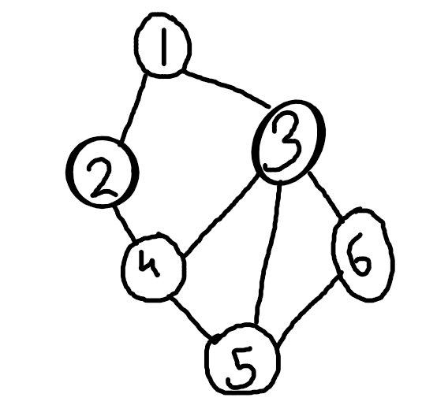
.

Consider the following graph, it’s BFS traversal would be

1, 2, 3, 4, 5, 6

B) DFS Algorithm

DFS is Depth Frst Search tree
Algorithm for depth-first search in a graph G beginning at a starting node A
Step 1: SET STATUS = 1 (ready state) for each node in G.
Step 2: Push the starting node A on the stack and set its STATUS = 2 (waiting state)
Step 3: Repeat Steps 4 and 5 until STACK is empty
Step 4: Pop the top node N. Process it and set its STATUS = 3 (processed state).
Step 5: Push on to the stack all the neighbours of N that are in the ready state (whose
STATUS = 1) and set their STATUS = 2 (waiting state)
[END OF LOOP]
Step 6: EXIT

.

Consider the above graph, it’s DFS traversal would be:

1, 2, 4, 3, 6, 5

